Ideation Phase
Empathize & Discover

Date | 5 September 2026
Team ID | SWUID2026190360
Project Name | Metro Ticket Generating System in ServiceNow
Maximum Marks | 4 Marks

Empathy Map Canvas:
An empathy map is a simple, easy-to-digest visual that captures knowledge about a user’s behaviours and attitudes.

It is a useful tool to helps teams better understand their users.
Creating an effective solution requires understanding the true problem and the person who is experiencing it. The exercise of creating the map helps participants consider things from the user’s perspective along with his or her goals and challenges.
Example:


Reference: https://www.mural.co/templates/empathy-map-canvas

Example: Food Ordering & Delivery Application
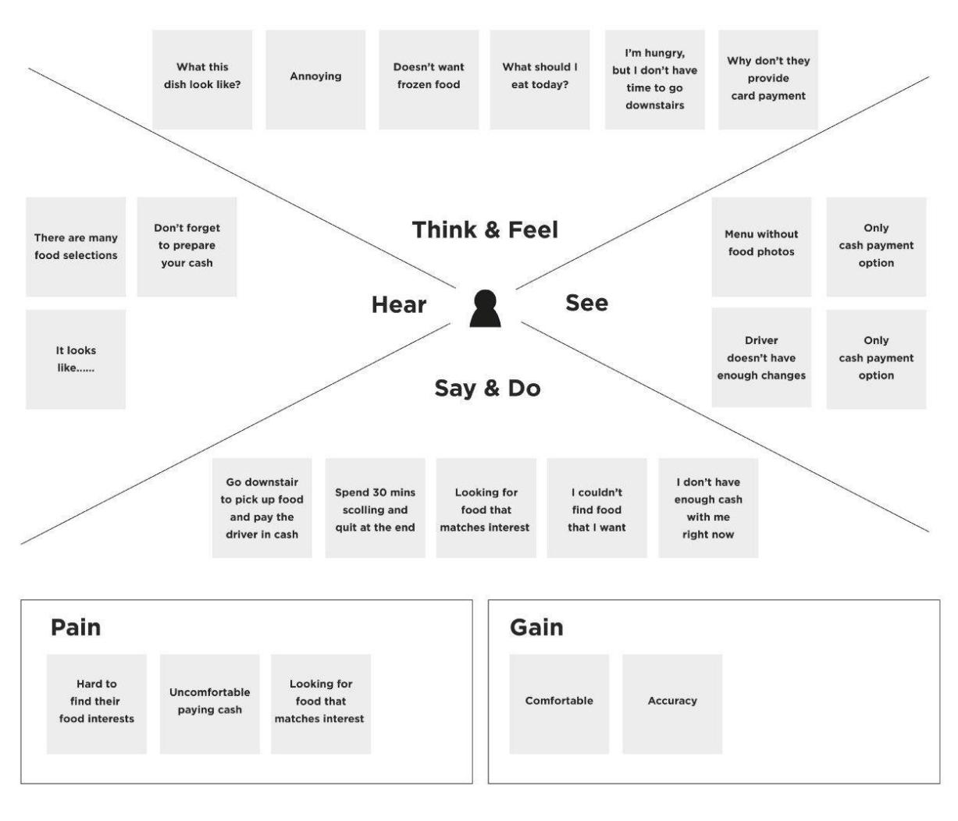

Empathy Map – Metro Ticket Generating System
User Persona: Metro Passenger / Commuter
This empathy map captures the passenger's behaviours, attitudes, goals, and challenges while booking and using metro tickets.
THINK & FEEL
• Wants a fast and simple ticket booking process.
• Worries about long queues and delays during peak hours.
• Prefers accurate fare calculation without manual confusion.
• Feels comfortable with secure digital payment options.
• Wants a digital ticket that is easy to access and verify.
HEAR
• Hears other passengers discussing long queues and waiting time.
• Hears that digital payments are faster and convenient.
• Receives information about QR-based entry and digital tickets.
• Hears feedback about ticketing errors or incorrect fare calculation.
SEE
• Sees queues at ticket counters during busy periods.
• Sees passengers using mobile phones for digital payments.
• Sees QR codes being used for digital access and verification.
• Sees different metro stations and route options.
SAY & DO
• Selects the starting station and destination.
• Chooses single or return journey.
• Selects the number of passengers.
• Checks the fare before confirming the booking.
• Chooses a payment mode such as UPI or card.
• Uses the generated QR ticket at the station gate.
PAIN
• Long waiting time at ticket counters.
• Manual ticket booking can be inconvenient.
• Difficulty calculating the correct fare.
• Risk of losing or carrying a physical paper ticket.
• Need to repeat the booking process during busy periods.
GAIN
• Fast and convenient digital ticket booking.
• Automatic fare calculation.
• QR-based digital ticket for easy verification.
• Reduced waiting time and manual effort.
• Cashless payment options.
• Easy access to ticket and journey information.
Key User Need:
A simple, fast, and reliable digital metro ticketing experience that allows passengers to select stations, calculate fares automatically, pay digitally, and receive a QR-based ticket.

